2017“转化·创造”第七届“刘开渠奖”国际雕塑大展初审入选作品名单
序号 | 作者 | 作品 | 入围作品图片
1 | Chen Gang | Shape of a Stone | 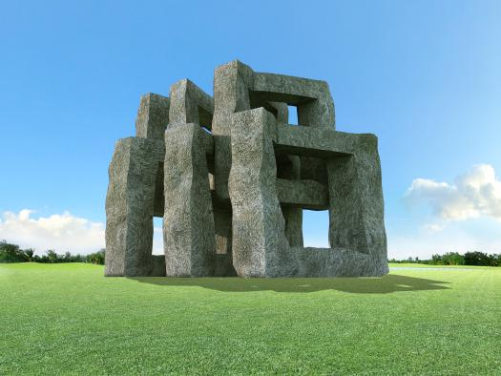
2 | Chen Qiang | Square·Round | 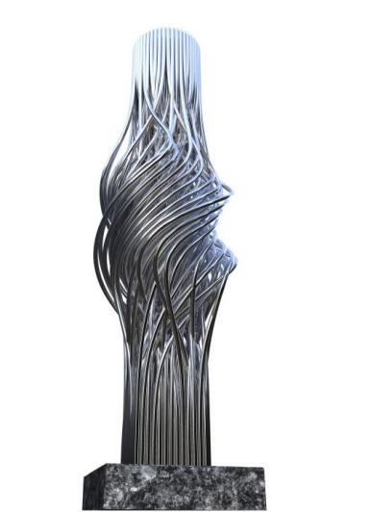
3 | Chen Tao | Turn | 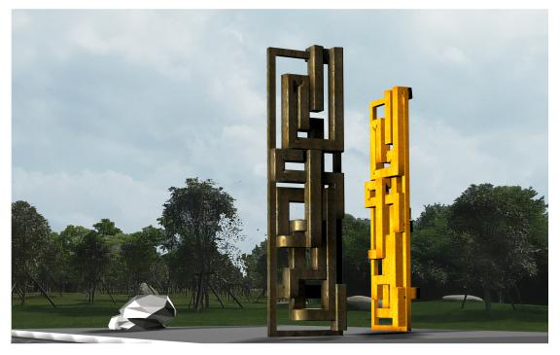
4 | Dong Yiyou | Still Waters Run Deep | 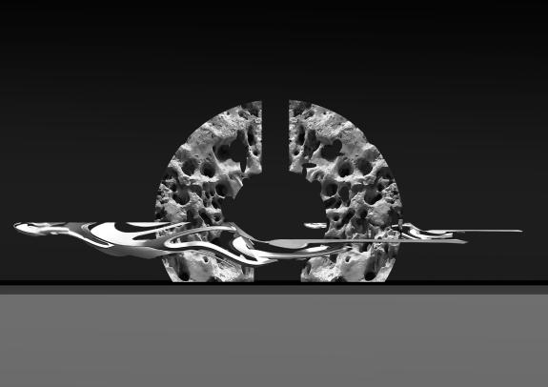
5 | Fan Wenbo | Kiss | 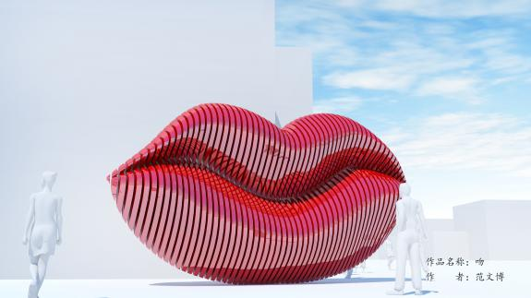
6 | Guoqi | Story of the Opera | 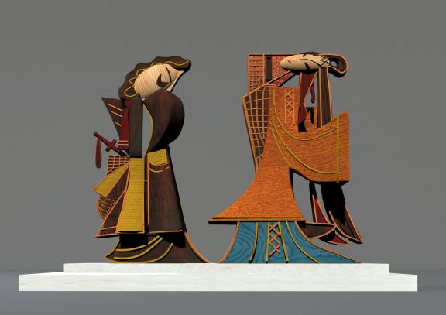
7 | Li Dongliang | Spring Lark | 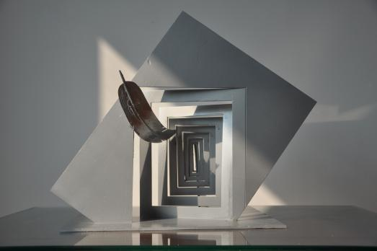
8 | Li Leilei | New Horse Stepping on Flying Swallow--Dream Seeking | 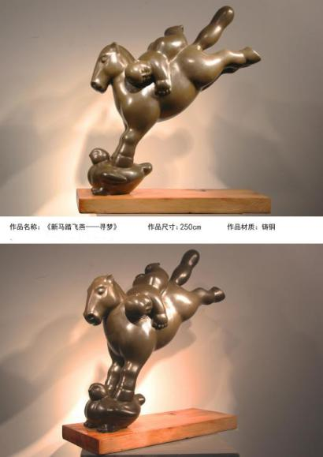
9 | Lin Gang | Knocking Stone Voicelessly | 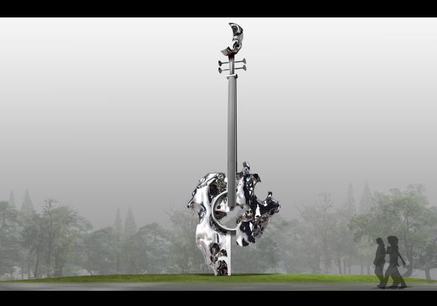
10 | Lin shenghuang | Through the Veil of Time Temple of Culture | 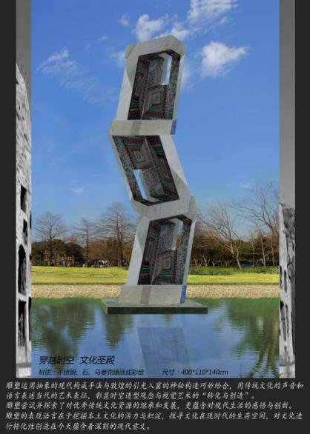
11 | Guo Zimng | Flowers yet not Flowers Leaves yet not Leaves | 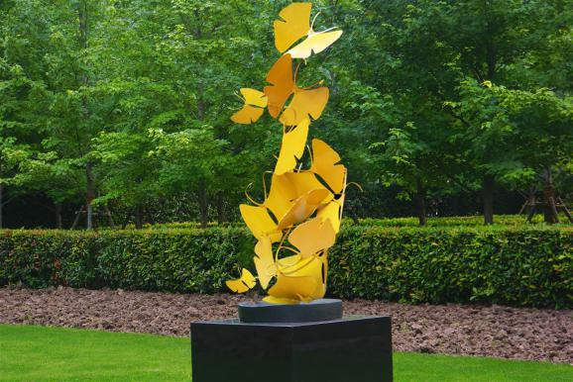
12 | Qu Kainan | Space-shifting Series--Door No.1 | 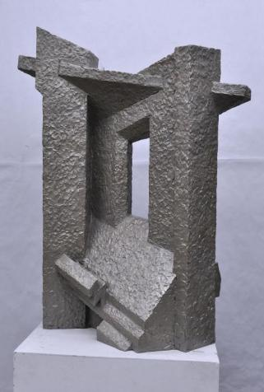
13 | Yao Yanling | Open-up Space--Yellow | 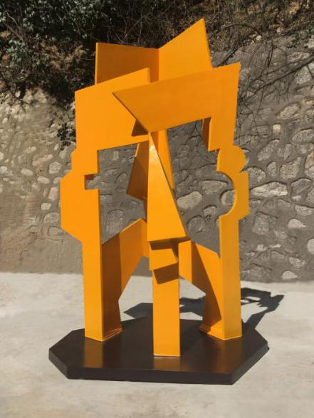
14 | Wu Lan | Boat | 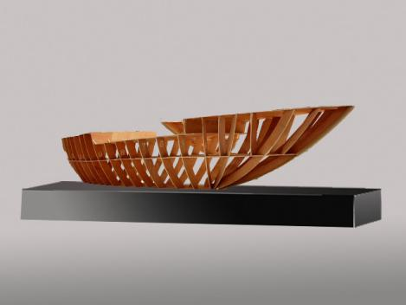
15 | Wu Pei | Hui Rhyme | 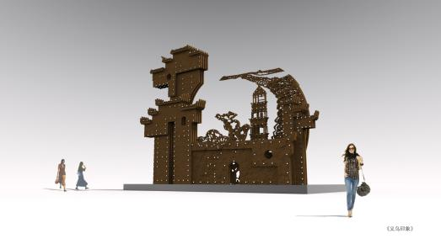
16 | Xie Wenkai | Lord | 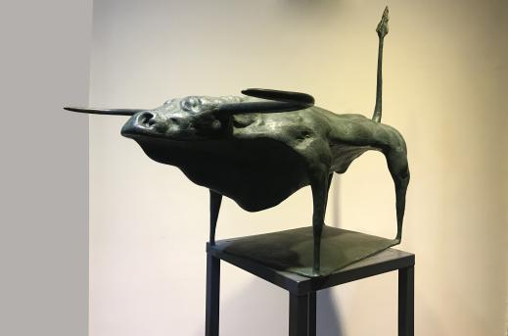
17 | Xu Kan | Flow | 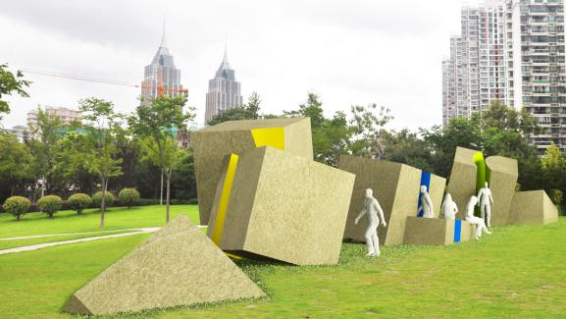
18 | Yang Jian | Dome | 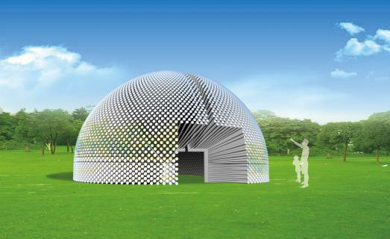
19 | Zhu Yuan | Conception in Sight | 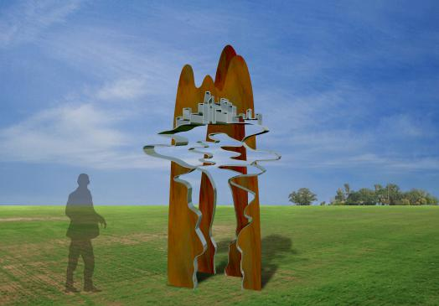
20 | Li Pengcheng | Oxygen Starving No.1 | 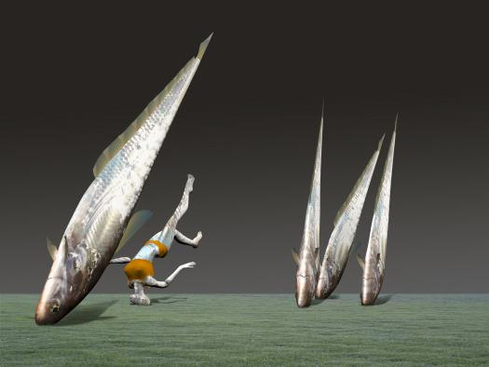
21 | Ding Hao | Babel | 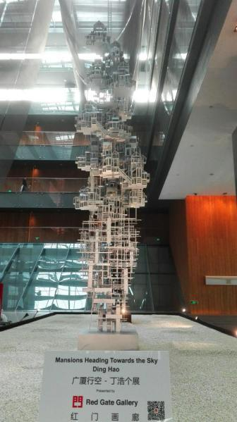
22 | He Zhenhai | Gate of Happiness and Longevity No.3 | 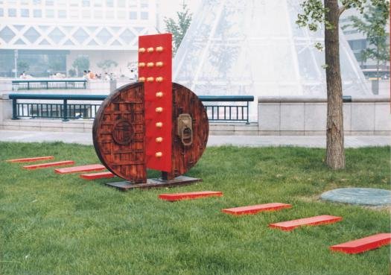
23 | Huang Qicheng | Cloud between Figures | 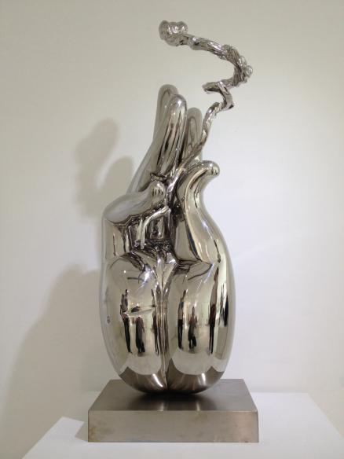
24 | Li Yunlong | Boating | 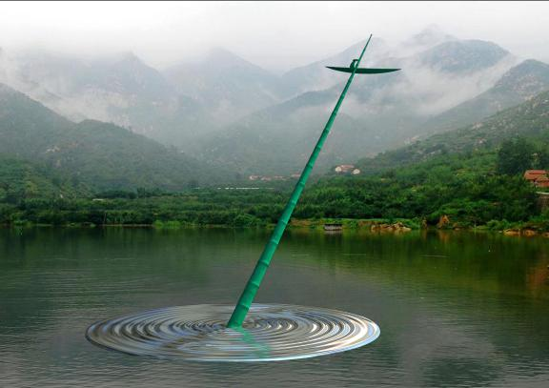
25 | Liu Qin | Dangyang Bridge | 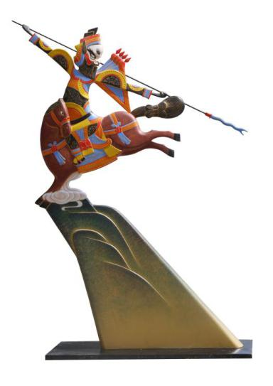
26 | Lv Shaofan | Tai Chi--Commencing Form | 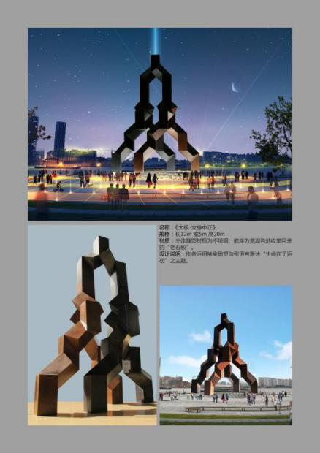
27 | Wang Xinggang | Ahh, My Balloon | 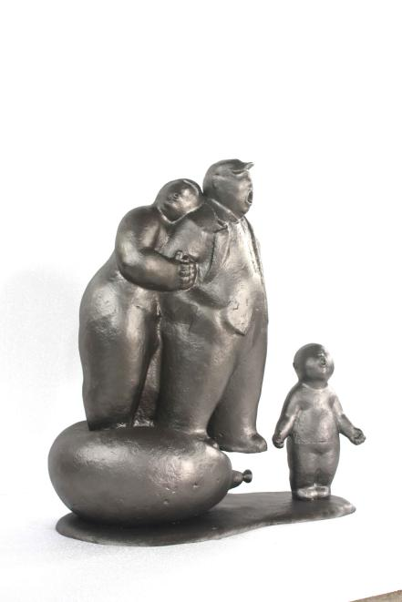
28 | Xu Zhenzhen | Sunrise | 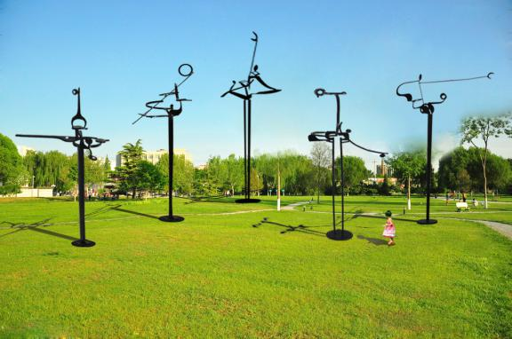
29 | Zhang Yaping | The Forgotten City Texture No.1 | 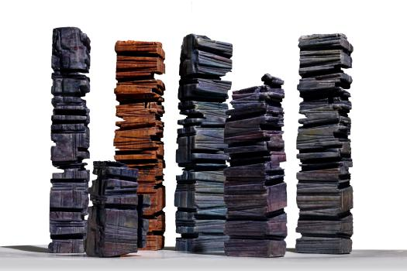
30 | Qian Yunke | Tree at Heart | 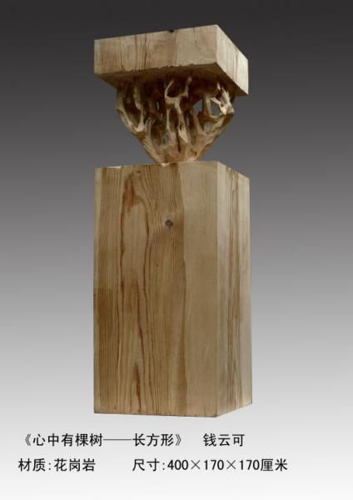
31 | Shi Xueliang | The Taming of Dream No.2 | 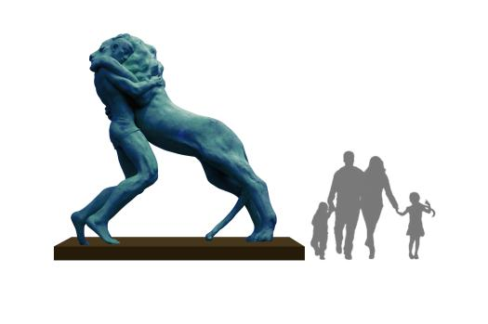
32 | Li Youwei | Far Away | 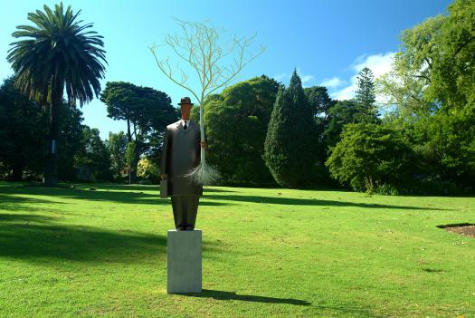
33 | Liu Yong | Impression Sunrise | 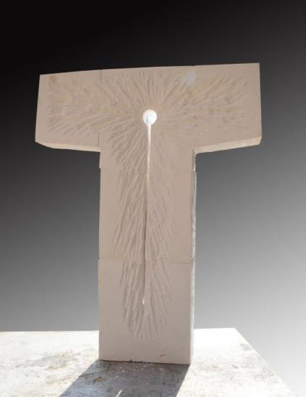
34 | Ma Mingtao | Constant Heaven Movement | 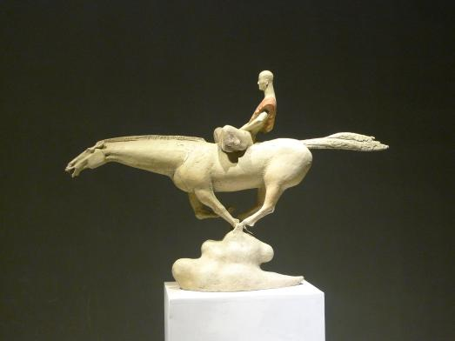
35 | Shi Qianli | Ink Painting of Landscape | 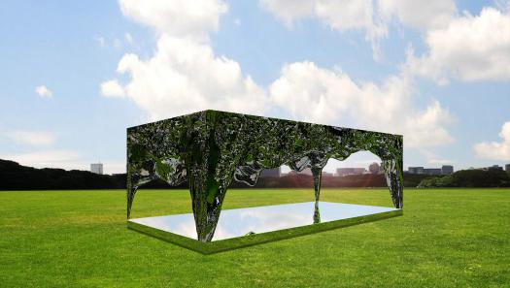
36 | Wu Zhiyong | A Massive Rock | 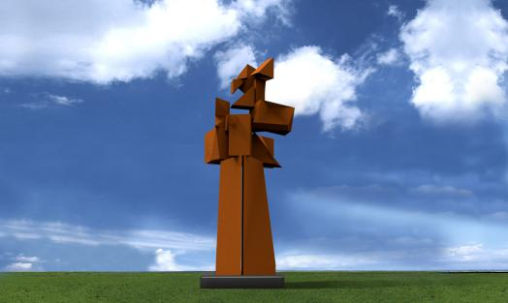
37 | Alexey Kanis  (Russia) | Cow with Calf | 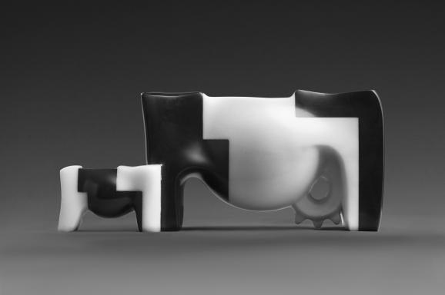
38 | Antonio Vigo  (Spain) | Change | 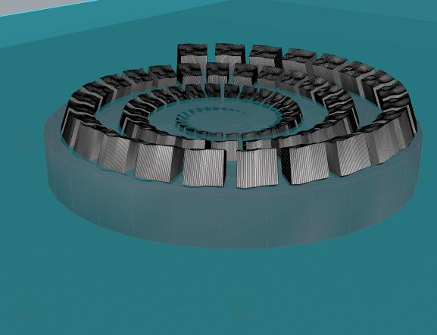
39 | Chablais  (France) | Dancing Figures | 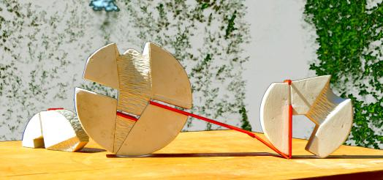

40 | Gemma Dominguez  （Spain） | Transition | 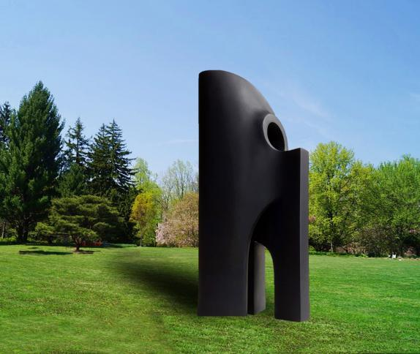
41 | Tavanxhiu Genti  (Italy) | Fragile | 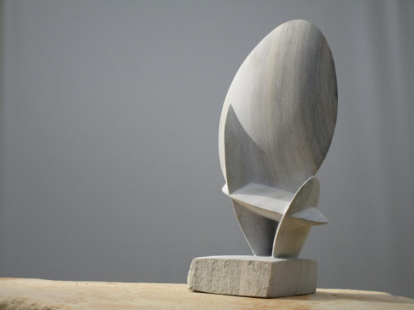
42 | Jörg Plickat  (Germany) | Building Human Bridges | 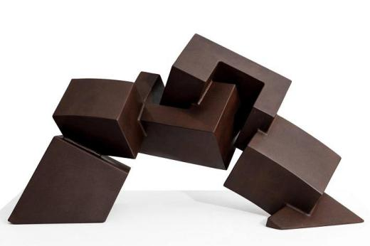
43 | Karin Van Ommeren （Netherlands） | The Node | 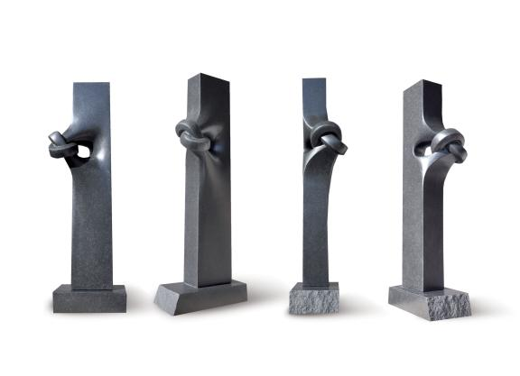
44 | Miguel Isla  (Spain) | Mythodea | 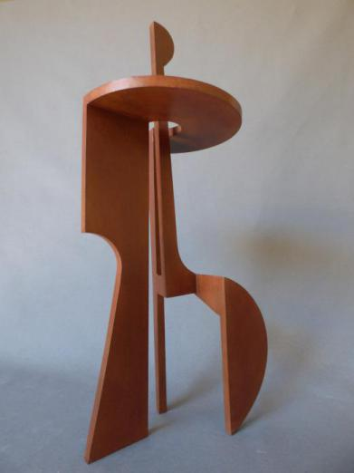
45 | Nando Alvarez  (Spain) | Sea Shell Wave | 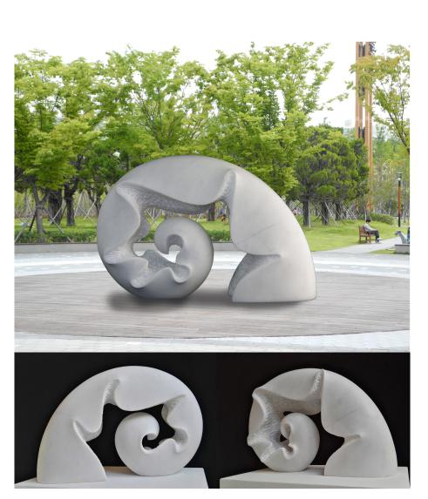
46 | Radoslav Sultov  （Bulgaria） | Sinchronicity | 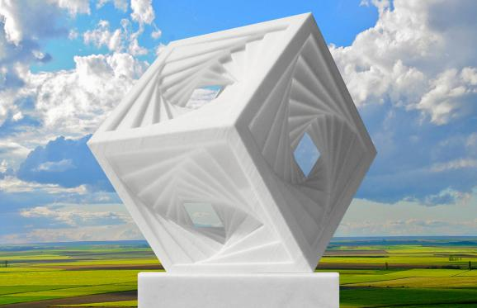
47 | Gwon Ji Gye  (Korea) | Resilience--Full Moon | 